Photolithography
Introduction

Photolithography has been used for many years in the fabrication of integrated circuits, transistors, and MEMS devices. The underlying principal of photolithography relies on the way certain polymeric compounds called photoresists respond to exposure by ultraviolet (UV) light. Areas that have been exposed to UV will exhibit selective solubility in a developing solution. There are two main types of photoresist – positive and negative. A positive resist will result in an exact copy of what is on the master pattern, while a negative resist will result in the inverse pattern. The photolithography process presented in this lab is capable of resolving features down to approximately 0.5 micron. The method of photolithography used in this lab is called contact photolithography and a generalized process flow is presented in Figure 1.

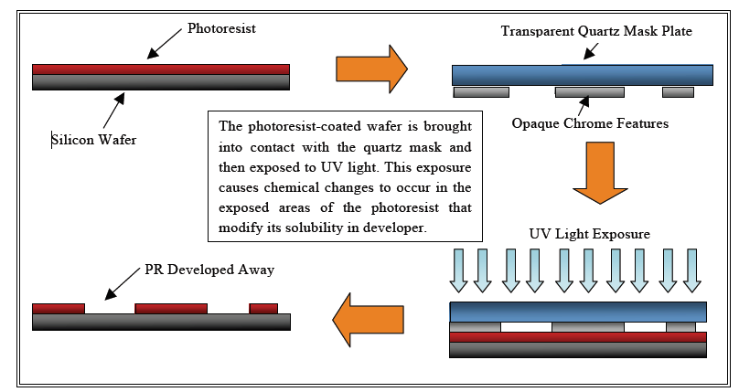
Figure 1: Generalized contact photolithography process. When the exposure is completed, the wafer is submerged in a developer to wash away the cross-linked sections of photoresist. The end result is an exact copy (or the inverse, if using a negative photoresist) of what is opaque on the mask plate.

Purpose of the experiment

The purpose of this experiment is to provide an introduction to, and hands-on experience with standard photolithographic techniques that are used to pattern a silicon wafer. We will perform all the steps in the photolithography process, and examine the patterned wafer under a microscope.

Equipment

The experiment equipment includes
- Electric hot plates to heat and bake wafers.
- Spinner to thin and flatten photoresist layer.
- Mask Aligner MJB3, which is an exposure system that enables also an alignment of the wafer with features on the mask.
- Optical microscope.
- Plasma Asher machine.
- Electron-beam Evaporator VST 680.

Chemical substances:
- Solvents for wafer cleaning – acetone, isopropyl alcohol.
- Lift-Off Resist LOR5A.
- Positive photoresist AZ1505.
- Developer AZ726.
- Lift-off solvent – NMP.
- N₂ gun for drying the wafers.

Procedures

1. Preparation.
  - Rinse a SiO₂ wafer with Acetone and isopropyl alcohol.
  - Dry the SiO₂ wafer using an N2 gun.
  - Dehydrate the SiO₂ wafer at 180°C for 5 minutes.

2. Spin-coat LOR-5A
  - Place and center the wafer on the spinner chuck.
  - Set the following program:
- Step 1: 500rpm, 100rpm/s, for 10s
- Step 2: 3000rpm, 9000rpm/s, for 45s.
- Step 3: 0 rpm, 1000rmp/s, for 0s. (stopping)
  - Pour enough LOR-5A onto the wafer to cover the surface area.
  - Activate the spinner and wait until it automatically stops.
  - Soft bake the wafer at 180°C for 5min.
- Spin-coat AZ1505
  - Place and center the wafer on the spinner chuck.
  - Set the following program:
- Step 1: 500rpm, 100rpm/s, for 10s
- Step 2: 5000rpm, 4500rpm/s, for 40s.
- Step 3: 0 rpm, 1000rmp/s, for 0s. (stopping)
  - Pour enough AZ1505 onto the wafer to cover the surface area.
  - Activate the spinner and wait until it automatically stops.
  - Soft bake the wafer at 110°C for 1.5min.

- Exposure.
  - Load the mask at the mask aligner and press VACUUM.
  - Place the wafer on the chuck of the mask aligner.
  - Raise the wafer to the mask and bring it to contact, then lower the wafer minimally until the aligner goes to SEPARATION mode.
  - Make adjustments to the wafer’s position using micrometric regulator for x, y and $θ$.
  - Set the exposure time to 2 sec.
  - Press the EXPOSE button to start the exposure. DO NOT LOOK AT THE UV LIGHT!
  - When the exposure is complete, slide the wafer tray out and remove the sample.

- Develop/Inspect.
  - Transfer the exposed wafer to the solvent hood.
  - Fill a clean dish with AZ726 Developer.
  - Submerge the wafer in the developer and agitate for 1min.
  - Rinse the developed wafer with copious amounts of DI water.
  - Dry the developed wafer using an N₂ gun.
  - Inspect the developed wafer with optical microscope.

- Plasma Asher.
  - Open the gas valves and turn on the machine.
  - Vent the chamber, open the door and insert the samples.
  - Close the door and press PUMP.
  - When the pressure goes below 0.3mbar, turn on both gases.
  - Wait until the pressure reach around 0.3mbar again.
  - Set the timer to 0.2min (=12sec), and the power to 2.5.
  - Press GENERATE and wait until the light of the button turns off.
  - Turn off the gases and pump, press VENT.
  - Take out the samples.

- Gold Deposition.
  - Use the Evaporator to deposit 2 layers: 2nm Cr, 50nm Au.

- Lift-Off
  - Soak the samples in NMP, seal with paraffin. Leave for a few hours.
  - Take the samples out, wash with water and dry with N₂ gun.

Preparation questions
- Summarize briefly the photolithography process steps.
- There are two main types of photo resist, positive resist and negative resist. What are the changes of each type after the exposure to light? For which purpose each one is used?
- What is the resolution photolithography process?
- What is the purpose of prebake and postbake?
- The photolithography process is done only in a room with yellow lighting. What if we expose the substrate to a fluorescent light before the development? and after the development?
- Estimate the minimal line width that can be printed by contact-printing photolithography, when using a wavelength of $λ=248nm$ and a photoresist thickness of 0.5nm.

